TO: Data Analytics & Visualization Boot Camp

FROM: Trevor Kulbeth

DATE: January 22, 2019

SUBJECT: Unit #1 | Assignment – Kickstart my Chart

Report Summary

Data for this analysis was taken from the popular crowd funding site Kickstarter from the year 2009 to 2017. This study analyzed the data to determine the success of all the projects over the years based on category, sub category and month in which the Kickstarter project begun. In this analysis trends in which projects are most likely to succeed, which are most popular, what types of project have the highest chances for success could be determined.

**Analysis**

In analyzing every project by category, the four most popular categories to receive funding from highest to lowest are theater, music, technology, and film and video. Theater is by far the most popular project to receive kickstart funding with more than 50% of these projects being successful, followed by music, film and video and technology. Although the technology category is the third most popular category, of the four it is also one of the least successful categories in kickstart with more than half of the project being canceled or failing. In looking at the data shown it is safe to infer that project in theater and music have the highest chance of success in kickstart.

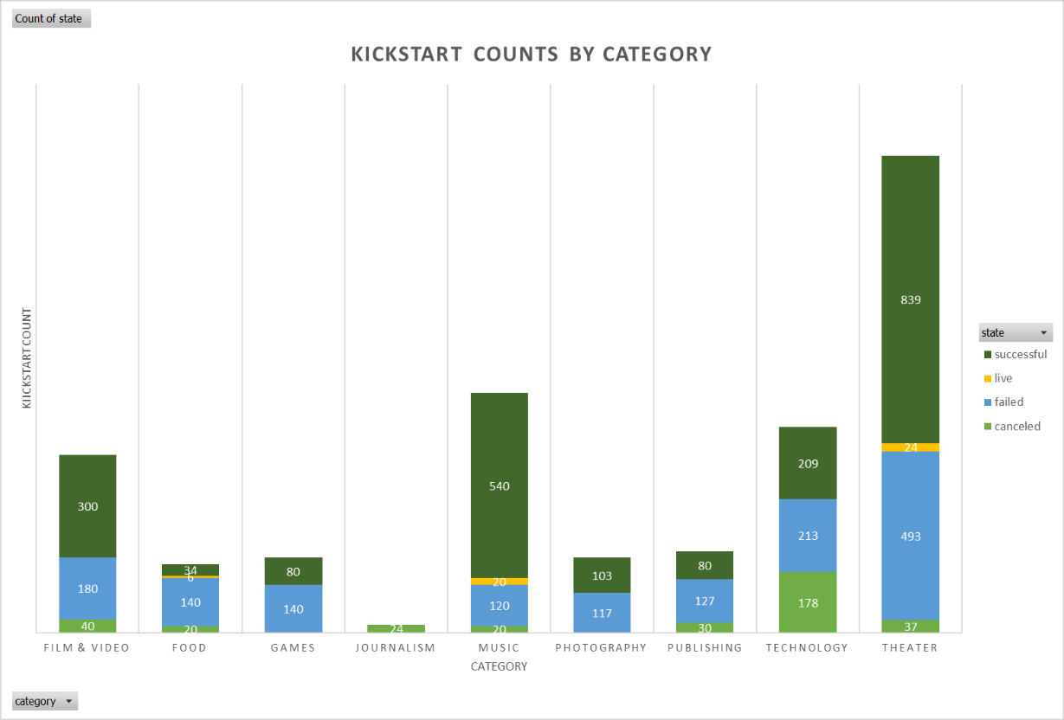

By subcategory the trend, noticed in the previous analysis was also noted. The play sub-category was by far the most popular crowd funding project on kickstart and highly successful. In each subcategory a noticeable trend also developed among the most popular forms of entertainment where often the most popular forms of entertainment were nearly always successful. This indicates that what is often more popular has a higher chance for success on kickstart.

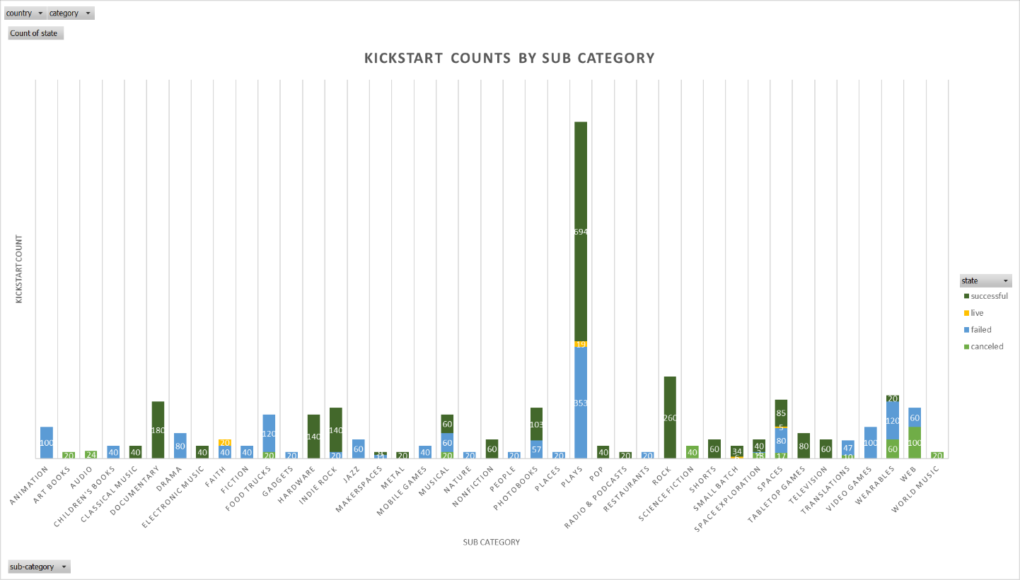

Analyzing the correlation between the month the project began verses the projects successfulness indicates that the best time to begin a project is between February and May. During these months the difference between the successful project counts and the projects that fail are the greatest, lending to a greater chance of success for these projects.

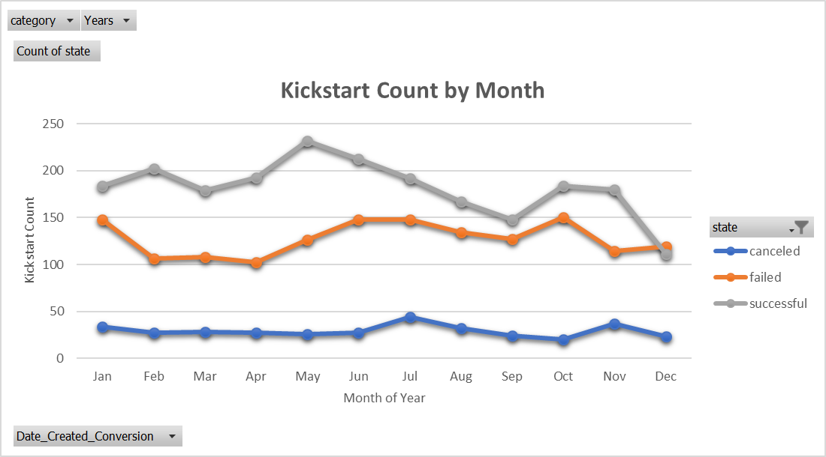

**Limitations**

Although the data used in this analysis is representative of all projects started in Kickstart, there are some limitations of the data that must be recognized.

1. **Data Correlation:** There may be other factors outside of a projects popularity that may impacting the success of a project that aren’t captured within the scope of the data. These may include, demographics, number of contributors, country of origin, etc.

**Future analysis**

The analysis in this report only look at the categorial success of projects funded by kickstart. Some ideas for future analysis are included here.

1. The correlation between the success rate and the funding goal for the project
2. How many backers there are on a project vs category and sub category; to determine if more categories get more backers than others
3. Average donation per category and subcategory; to determine if a particular category or sub category get more funding.
4. Average donation per funding goal for each project: to determine weather larger projects get larger donations or just have more contributors.